What to look for when changing Trackmaster™ batteries

Thomas Trackmaster engines have several different types of battery compartments. The battery compartment on most engines can be accessed by loosening one Phillips-head screw.
For single engines, check the bottom of the vehicle for a Phillips-head screw near the front or back. There will usually be a small arrow near the screw that should be loosened.

Do not remove these screws: Phillips-head battery compartment screw:
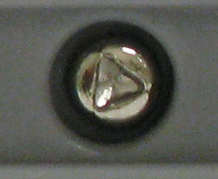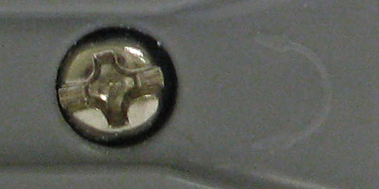
Once the screw is loosened, the top of the vehicle can be lifted off to reveal the battery compartment. Note that the screw only needs to be loosened and will not come out of the bottom of the vehicle.
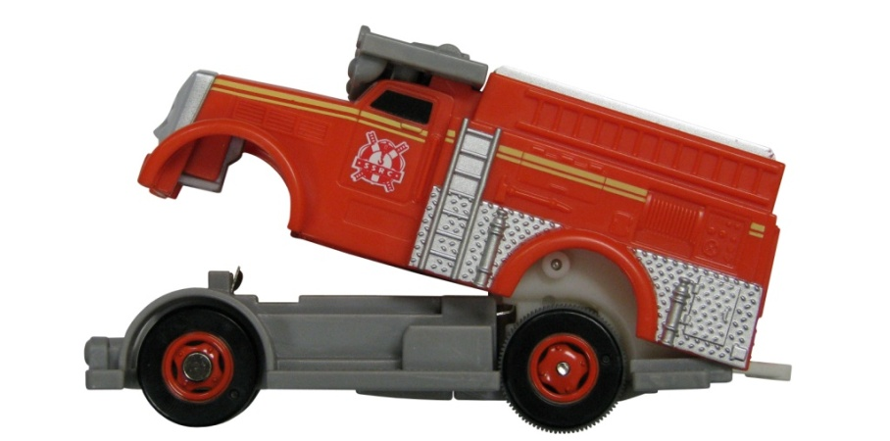
Some single engines have the Phillips-head battery compartment screw on the bottom, near the center. On some models, once the screw is loosened, the bottom center piece of plastic containing the Phillips-head screw will detach and you will have to pinch the sides of the engine, near the center, to release the top from the bottom, as seen below.
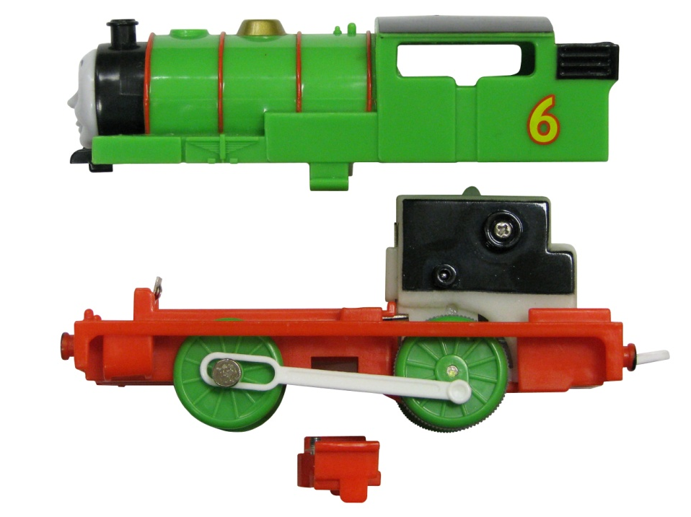
Engines permanently attached to a tender car generally have the Phillips-head battery compartment screw on the top of the tender car. Once the screw is loosened, it will remain in the battery compartment door and the top can simply be lifted off, as seen below.
*Note that some remote control engines with tender cars have 2 battery compartments: one in the engine and one in the tender car.

If you are still having difficulty accessing the battery compartment on your Thomas Trackmaster engine, please contact us here: http://fp-fami.ly/hzikCN. We would be happy to help!

