nabi Jr Factory Reset

- Turn off your nabi Jr.
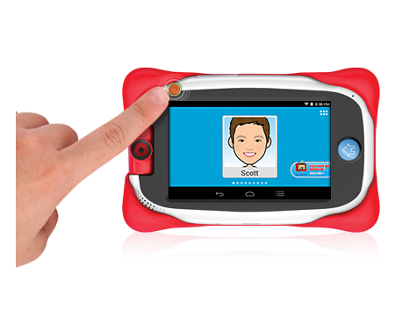
- Press and hold the Volume + button and the Power button until the system menu appears on the upper left corner of the screen.
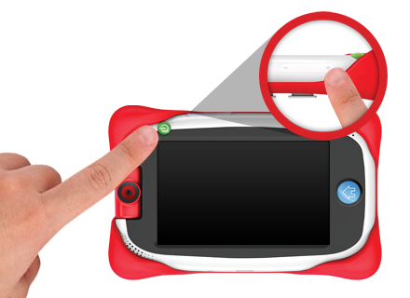
- Use the Volume - button to select “Android Recovery Mode.”
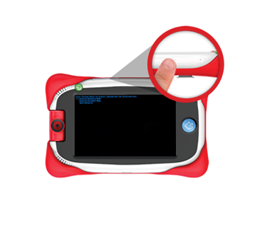
- From the Android screen, press and hold the Volume - button then tap the Volume + button
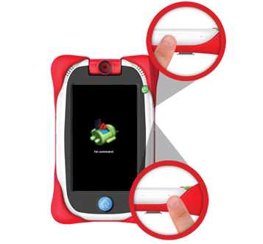
- Use the Volume - button to highlight “Wipe Data/Factory Reset.” Then, press the Power button to select that.
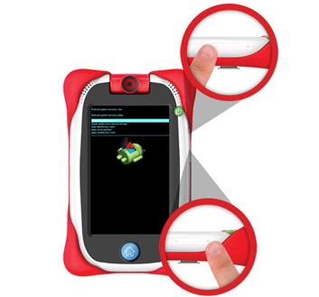

- Use the Volume - button again to highlight “Yes - Delete All User Data” and press the Power button to select that.

- When the data wipe is complete (about 20 minutes), reboot system now will be highlighted. Press the Power button to select that to reboot your nabi.
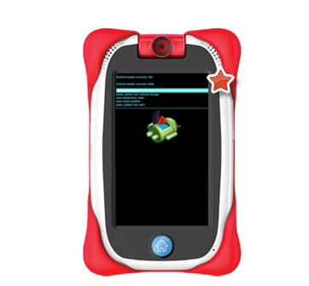

- It will take about five minutes to reboot your nabi Jr. Once the initialization is complete, your consumer will see the Welcome screen.
